# UNIT 9: FESTIVAL AROUND THE WORLD

##### GRAMMAR - NGỮ PHÁP

1. **H/WH-QUESTIONS:** Câu hỏi với các từ bắt đầu bằng H/Wh

###### Cấu trúc

**Question word + auxiliary + subject + main verb + rest of question?**

(Từ để hỏi + trợ động từ + chủ ngữ + động từ chính + phần còn lại?)

##### Ví dụ:

When does she come home? (Khi nào thì cô ấy về nhà?)

##### Hoặc: Question word + be + subject + rest of question?

(Từ để hỏi + động từ to be chia theo ngữ cảnh + chủ ngữ + phần còn lại?)

##### Ví dụ:

What is your favorite food? (Món ăn ưa thích của bạn là gì?)

##### Hoặc: Question word + main verb + rest of question?

(Từ để hỏi + động từ chính + phần còn lại?)

##### Ví dụ:

Who owns this pencil? (Chiếc bút chì này là của ai?)

###### Cách dùng

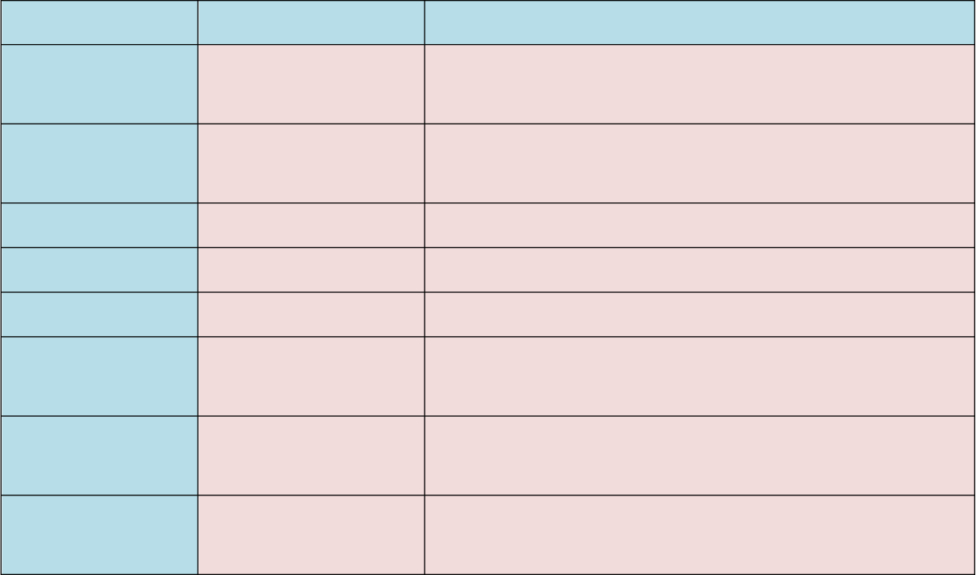

**Loại câu hỏi**

**Đối tƣợng hỏi**

What

một mệnh đề

Which

**Cách dùng**

What do you often have for breakfast? (Bạn thường ăn điểm tâm bằng gì?)

một mệnh đề (giới Which will you have, tea or coffee? (Bạn muốn hạn câu trả lời) uống gì, trà hay cà phê?)

Why

nguyên nhân

Whose

thuộc sở hữu của

ai

How

cách thức

Why do you go to office late? (Tại sao bạn đến cơ quan trễ?)

Whose books are you reading? (Bạn đang đọc quyển sách của ai?)

How many dogs do you have? (Bạn có bao nhiêu

con chó?)

|  |  |  |
| --- | --- | --- |
| Who | người | Who wants a coffee? (Ai muốn uống cà phê?) |
| When | thời gian | When do you see him? (Bạn gặp anh ta khi nào?) |
| Where | địa điểm | Where do you live? (Bạn sống ở đâu?) |

* 1. **Dấu hiệu nhận biết**
     + Ở đầu câu luôn xuất hiện các từ để hỏi sau: What, Who, When, Where, Why, Which, Whose, How.
     + Trong văn nói: Lên giọng ở đầu câu và xuống giọng ở cuối câu.

###### Một số lưu ý trong dạng câu hỏi H/Wh

* + - Các cách viết tắt thường gặp: Who is = Who's

What will = What'll

##### Ví dụ:

Who's celebrating the festival? What'll they have in the festival?

1. **ADVERBIAL PHRASES** - Cụm trạng từ

###### Cấu trúc

* + - Cụm trạng từ có thể là danh từ, giới từ hoặc động từ nguyên mẫu.
    - Cụm trạng từ có thể là một từ hoặc là một cụm từ có các thành phần bổ nghĩa. Ví dụ:

After breakfast/ Before lunch Usually/ Often/ Sometimes/ Barely Late/ Very early/ On time

Here/ There/ Over there

In the funniest way/ Much funnier than usual Etc.

###### Cách dùng chính

* + - Cụm trạng từ có thể được dùng để trả lời cho các câu hỏi "How", “When", "Where", "Why".

##### Ví dụ

How often do people hold the Flower Festival? (Người ta tổ chức Lễ Hội Hoa bao lâu một lần?)

When does the Flower Festival take place? (Lễ hội Hoa diễn ra lúc nào?)

Where does the Flower Festival take place? (Lễ hội Hoa diễn ra ở đâu?)

Why do people go to Dalat Flower festival? (Lễ hội Hoa Đà Lạt được tổ chức để làm gì?)

The Festival is held once a year. (Lễ hội được tổ chức 1 năm 1 lần)

The Festival takes place from 30 Dec 2015 through 03 Jan 2016 (Lễ hội diễn ra từ ngày 30 tháng 12 năm 2015 đến ngày 03 tháng

01 năm 2016)

The Festival takes place in Dalat, Vietnam. (Lễ hội diễn ra tại Đà Lạt, Việt Nam)

They go to Dalat Flower Festival to honor the value of flowers and floriculture. (Mọi người tham dự Lễ hội Hoa Đà Lạt để tôn vinh giá trị của hoa và nghề trồng hoa)

* + - Cụm trạng từ có thể đứng ở các vị trí khác nhau trong câu.

##### Ví dụ:

* In spring, people go to Dalat Flower Festival to enjoy beautiful flowers. (Vào mùa xuân, mọi người tham dự Lễ hội Hoa Đà Lạt để thưởng thức những bông hoa xinh đẹp)
* The parade and performance takes place after opening ceremony. (Màn diễu hành và biểu diễn diễn ra sau lễ khai mạc)
* People perform selected repertoires at several places around Xuan Huong Lake. (Người ta biểu diễn những tiết mục chọn lọc tại một vài địa điểm xung quanh Hồ Xuân Hương)

###### Dấu hiệu nhận biết

Cụm trạng từ trong câu là những từ hoặc cụm từ có chức năng như một trạng từ nhằm đưa thông tin về thời gian, địa điểm, cách thức... của một hành động.

##### VOCABULARY - TỪ VỰNG

|  |  |  |
| --- | --- | --- |
| **Từ mới** | **Phiên âm** | **Nghĩa** |
| anniversary (n) | /ˌænɪˈvɜːsəri/ | ngày kỷ niệm |
| celebrate (v) | /ˈselɪbreɪt/ | kỉ niệm, tôn vinh |
| ceremony (n) | /ˈserəməni/ | nghi thức, nghi lễ |
| Christmas (n) | /ˈkrɪsməs/ | lễ Giáng sinh |
| culture (n) | /ˈkʌltʃə(r)/ | văn hóa |
| Easter (n) | /ˈiːstə(r)/ | lễ Phục sinh |
| festival (n) | /ˈfestɪvl/ | lễ hội |
| firework (n) | /ˈfaɪəwɜːk/ | pháo hoa |
| holiday (n) | /ˈhɒlədeɪ/ | kì nghỉ |
| Independence Day (n) | /ˌɪndɪˈpendəns deɪ/ | ngày Quốc Khánh |
| parade (n) | /pəˈreɪd/ | diễu hành |
| party (n) | /ˈpɑːti/ | buổi tiệc |
| perform (v) | /pəˈfɔːm/ | biểu diễn |
| religious (adj) | /rɪˈlɪdʒəs/ | thuộc về tôn giáo |
| superstitious (adj) | /ˌsuːpəˈstɪʃəs/ | mê tín dị đoan |
| Thanksgiving (n) | /ˌθæŋksˈɡɪvɪŋ/ | lễ Tạ ơn |
| tourist (n) | /ˈtʊərɪst | khách tham quan |
| turkey (n) | /ˈtɜːki/ | gà tây |
| vacation (n) | /vəˈkeɪʃn/ | kì nghỉ dài |

1. **EXERCISES - BÀI TẬP THỰC HÀNH**

**PART 1. PHONETICS**

1. **Find the word which has a different stress pattern from the other. Read the words aloud.**

|  |  |  |  |
| --- | --- | --- | --- |
| 1. A. harvest | B. famous | C. design | D. festival |
| 2. A. holiday | B. tradition | C. vacation | D. activity |
| 3. A. outdoor | B. colorful | C. celebration | D. movement |
| 4. A. Monday | B. flower | C. occasion | D. joyful |
| 5. A. tourist | B. event | C. special | D. national |
| 6. A. music | B. costume | C. samba | D. America |
| 7. A. concert | B. countryside | C. concern | D. lantern |
| 8. A. surrounding | B. manner | C. stadium | D. famous |
| 9. A. Carnival | B. party | C. season | D. parade |
| 10. A. brighten | B. Birthday | C. delightful | D. present |

1. **Put the following words below in the correct column according to their stress pattern.**

|  |  |  |  |
| --- | --- | --- | --- |
| culture | enjoy | envelope | ancient |
| album | lucky | relative | fortune |
| display | ancestor | decorate | family |

|  |  |  |  |
| --- | --- | --- | --- |
| Muslim | modern | several | popular |
| annual | sacrifice  Stress on 1st syllable | lunar | symbol  Stress on 2nd syllable |

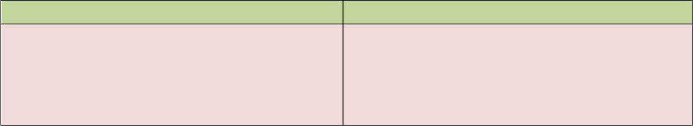**PART 2: VOCABULARY & GRAMMAR**

1. **Give the names of the following then read the words aloud.**

|  |  |
| --- | --- |
| a. | e. |
| b. | f. |
| c. | g. |
| d. | h. |

1. **Find one odd word A, B, C or D.**
   1. A. Tet holiday B. Easter C. Thanksgiving D. Monday
   2. A. tired B. joyful C. delightful D. happy
   3. A. sausage B. turkey C. beef steak D. Birthday cake
   4. A. candle B. lighting C. lantern D. moon
   5. A. sibling B. cousin C. friend D. relative

##### Make questions for the underlined parts in the following sentences, using the question words in the brackets.

###### Lunar New Year

1. New Year's Day is celebrated on the first day of the new year. (When)
2. In New Year's Eve, there are often fireworks at midnight. (What)
3. People celebrate New Year's Eve with fireworks at the stroke of midnight as the New Year starts. (How)
4. People often spend New Year with their family and relatives to remember and honor their ancestors. (Who)
5. Every family thoroughly deans the house to sweep away any ill-fortune and make way for good incoming luck. (Why)

###### Eid al-Adha (Festival of Sacrifice)

1. The festivities last for three days or more depending on the country. (How long)
2. The sacrificed animals must be at least a year old. (How old)
3. Eid al-Adha is celebrated by Muslims worldwide. (Who)
4. In the Islamic lunar calendar, Eid al-Adha falls on the 10th day of Dhu al-Hijjah and lasts for four days. (When and How long)
5. The Festival originated in the valley of Mecca (in present-day Saudi Arabia). (Where)

##### Underline adverbial phrases in following sentences.

* 1. We first met when he became the manager of the bank.
  2. I sometimes call on my younger sister when I'm in London
  3. After we had eaten, we played cards
  4. Take a packed lunch with you, in case you get hungry.
  5. There was a power failure earlier today and the trains are all running late now.
  6. He behaved in such a silly way I was ashamed of him.
  7. We served drinks as soon as our friends arrived.
  8. Dad found his change between the couch cushions.
  9. To track my running speed, I use a stopwatch.
  10. Carter put wood in the fireplace to keep the cabin warm.
  11. Christina went to the grocery store.
  12. The carpenter hit the nail with a hammer.

##### Each question has a sentence with an underlined phrase. Identify what TYPE of adverb phrase this is, using definitions in the box.

Manner time purpose frequency place

* 1. Joe buys flowers for his wife every week.
  2. Elephants are found in Africa and India.
  3. I’ll meet you on Friday.
  4. We hardly ever use the microwave.
  5. I bought the glue to fix my broken lamp.
  6. The woman stared at me with an angry expression.
  7. Surfing is a popular sport in the summer.
  8. Janice placed the chair next to the window.

##### PART 3: READING

1. **Fill in the blank with a word/ phrase in the box.**

to worship the Moon Genie

In the middle

through years

from a Chinese story

gradually

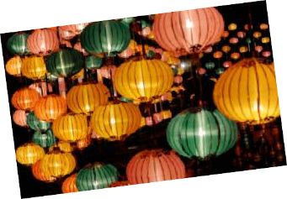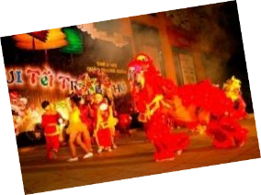

Mid-Autumn (Trung Thu) is the day when the moon is at its brightest in a year. In that spirit (1) , people in Vietnam as well as many Asian countries celebrate the Mid- Autumn's Festival. According to legends, this holiday is originated (2) in which an Emperor of Duong (Tang) Dynasty, Duong Minh Hoang, was taken to the moon by a wizard named La Cong Vien. (3) of his trip to the moon, the Emperor caught a glimpse of fairies in heaven celebrating the full moon. When Duong Minh Hoang was back to earth, he taught his citizens about the celebration and it became a custom lasting

(4) . Through times and times, Mid-Autumn's Festival (5) becomes an event providing children with a rich diversity of delightful traditional games and entertaining activities, offering great helps in promoting education as well as culture.

##### Read the passage and answer the questions.

Together with Bai Dinh and Yen Tu Pagoda Festival, Huong Pagoda Festival is among the greatest Buddhist festival in northern part of Vietnam. Huong Pagoda is located in My Duc District, 70 kilometers away from Hanoi to the south. This festival lasts for three months from the first to the third month in Lunar Calendar. In fact, the official opening day for the festival is on the 6th day of the first Lunar month. As other festivals in Vietnam, Huong Pagoda Festival is also divided into two parts: The ceremonies and the entertaining activities. Ceremonial rituals consist of incense offering procession and Zen ceremony in which Monks and Buddhists offer incense, flowers, candles and fruits. During the ceremony, there are two monks performing beautiful and flexible dances. On the other hand, entertaining activities include enjoying boat cruise along Yen Stream for watching picturesque scenery, climbing mountain and exploring holy caves. It is believed that climbing up the top of Huong Tich Mountain will bring you fulfillment and great success in life.

* 1. Where do people celebrate Huong Pagoda Festival?

..........................................................................................................................................

* 1. How long does the festival last?

..........................................................................................................................................

* 1. Which part of the festival do people climb the mountain?

..........................................................................................................................................

* 1. Why do people climb up the top of Huong Tich Mountain?

..........................................................................................................................................

##### PART 4: WRITING

1. **Arrange following phrases into a complete sentence.**
   1. Giong festival / different occasions / destinations / takes place in / depending on

..........................................................................................................................................

..........................................................................................................................................

* 1. Giong Festival / as an / of mankind / have been / intangible cultural heritage / recognized by UNESCO

..........................................................................................................................................

..........................................................................................................................................

* 1. Hung King / of the third Lunar month / is celebrated / Temple Festival / on the tenth day

..........................................................................................................................................

..........................................................................................................................................

* 1. Phu Tho / centuries ago / Province / where / the country / is a sacred land / Hung Kings established

..........................................................................................................................................

..........................................................................................................................................

* 1. Temple Festival / so on / in Hung King / traditional songs, chess playing, and / are/ Entertaining activities

..........................................................................................................................................

..........................................................................................................................................

* 1. Hung Kings - the country's founders / is to / worship / The purpose/ of this Festival

..........................................................................................................................................

..........................................................................................................................................